Task 1:

1. Create an POST request with no headers and body

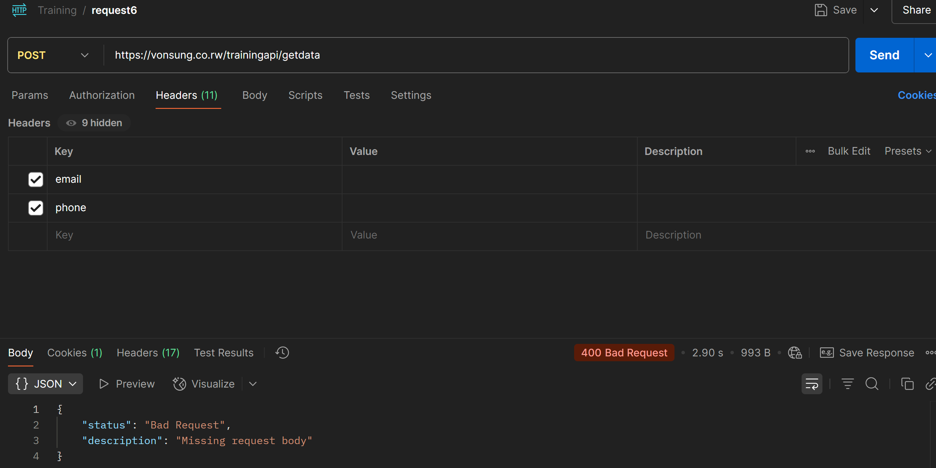

1. Adding an empty body:

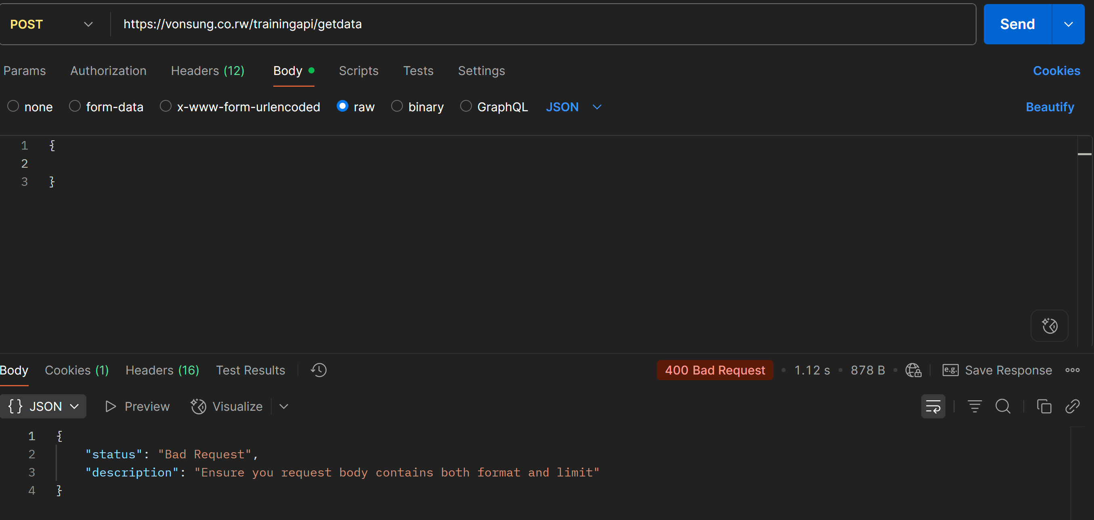

1. Add email and phone to the headers:

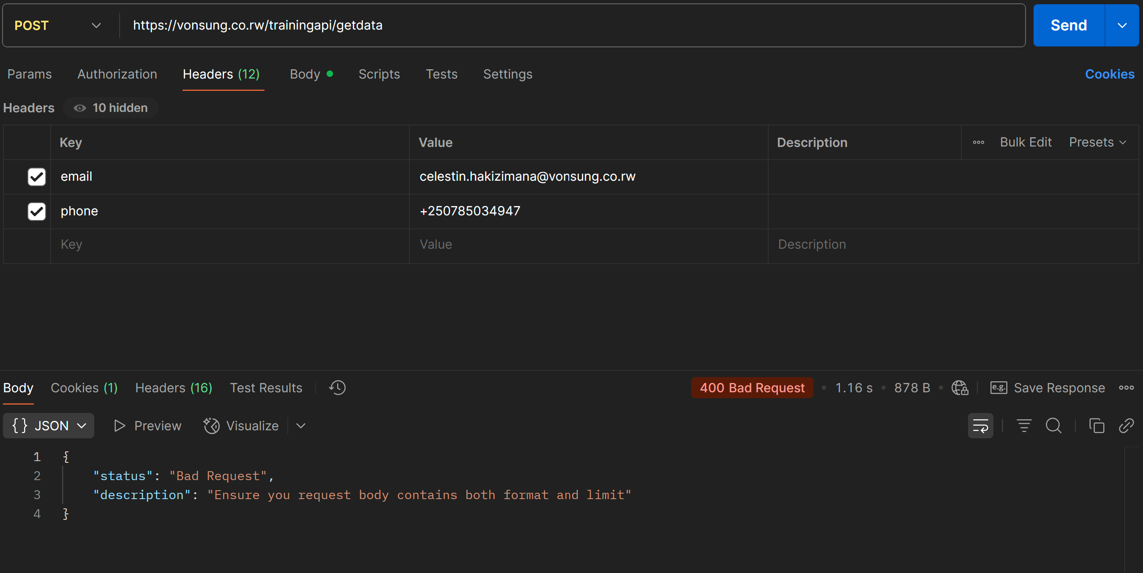

1. Define the format (set it to json) and limit (anything between 1-200).

